Lab 5.2- Maximo Antigua

Refer to Tutorial 4: Graphic Design with CSS

1. Complete Session 4.2 pages HTML 302 to HTML 323

Add a screenshot of the **tb_komatsu.html** file displayed in a browser after completing Step 3 on page HTML 323. Refer to Figure 4-44. Include the browser address bar.

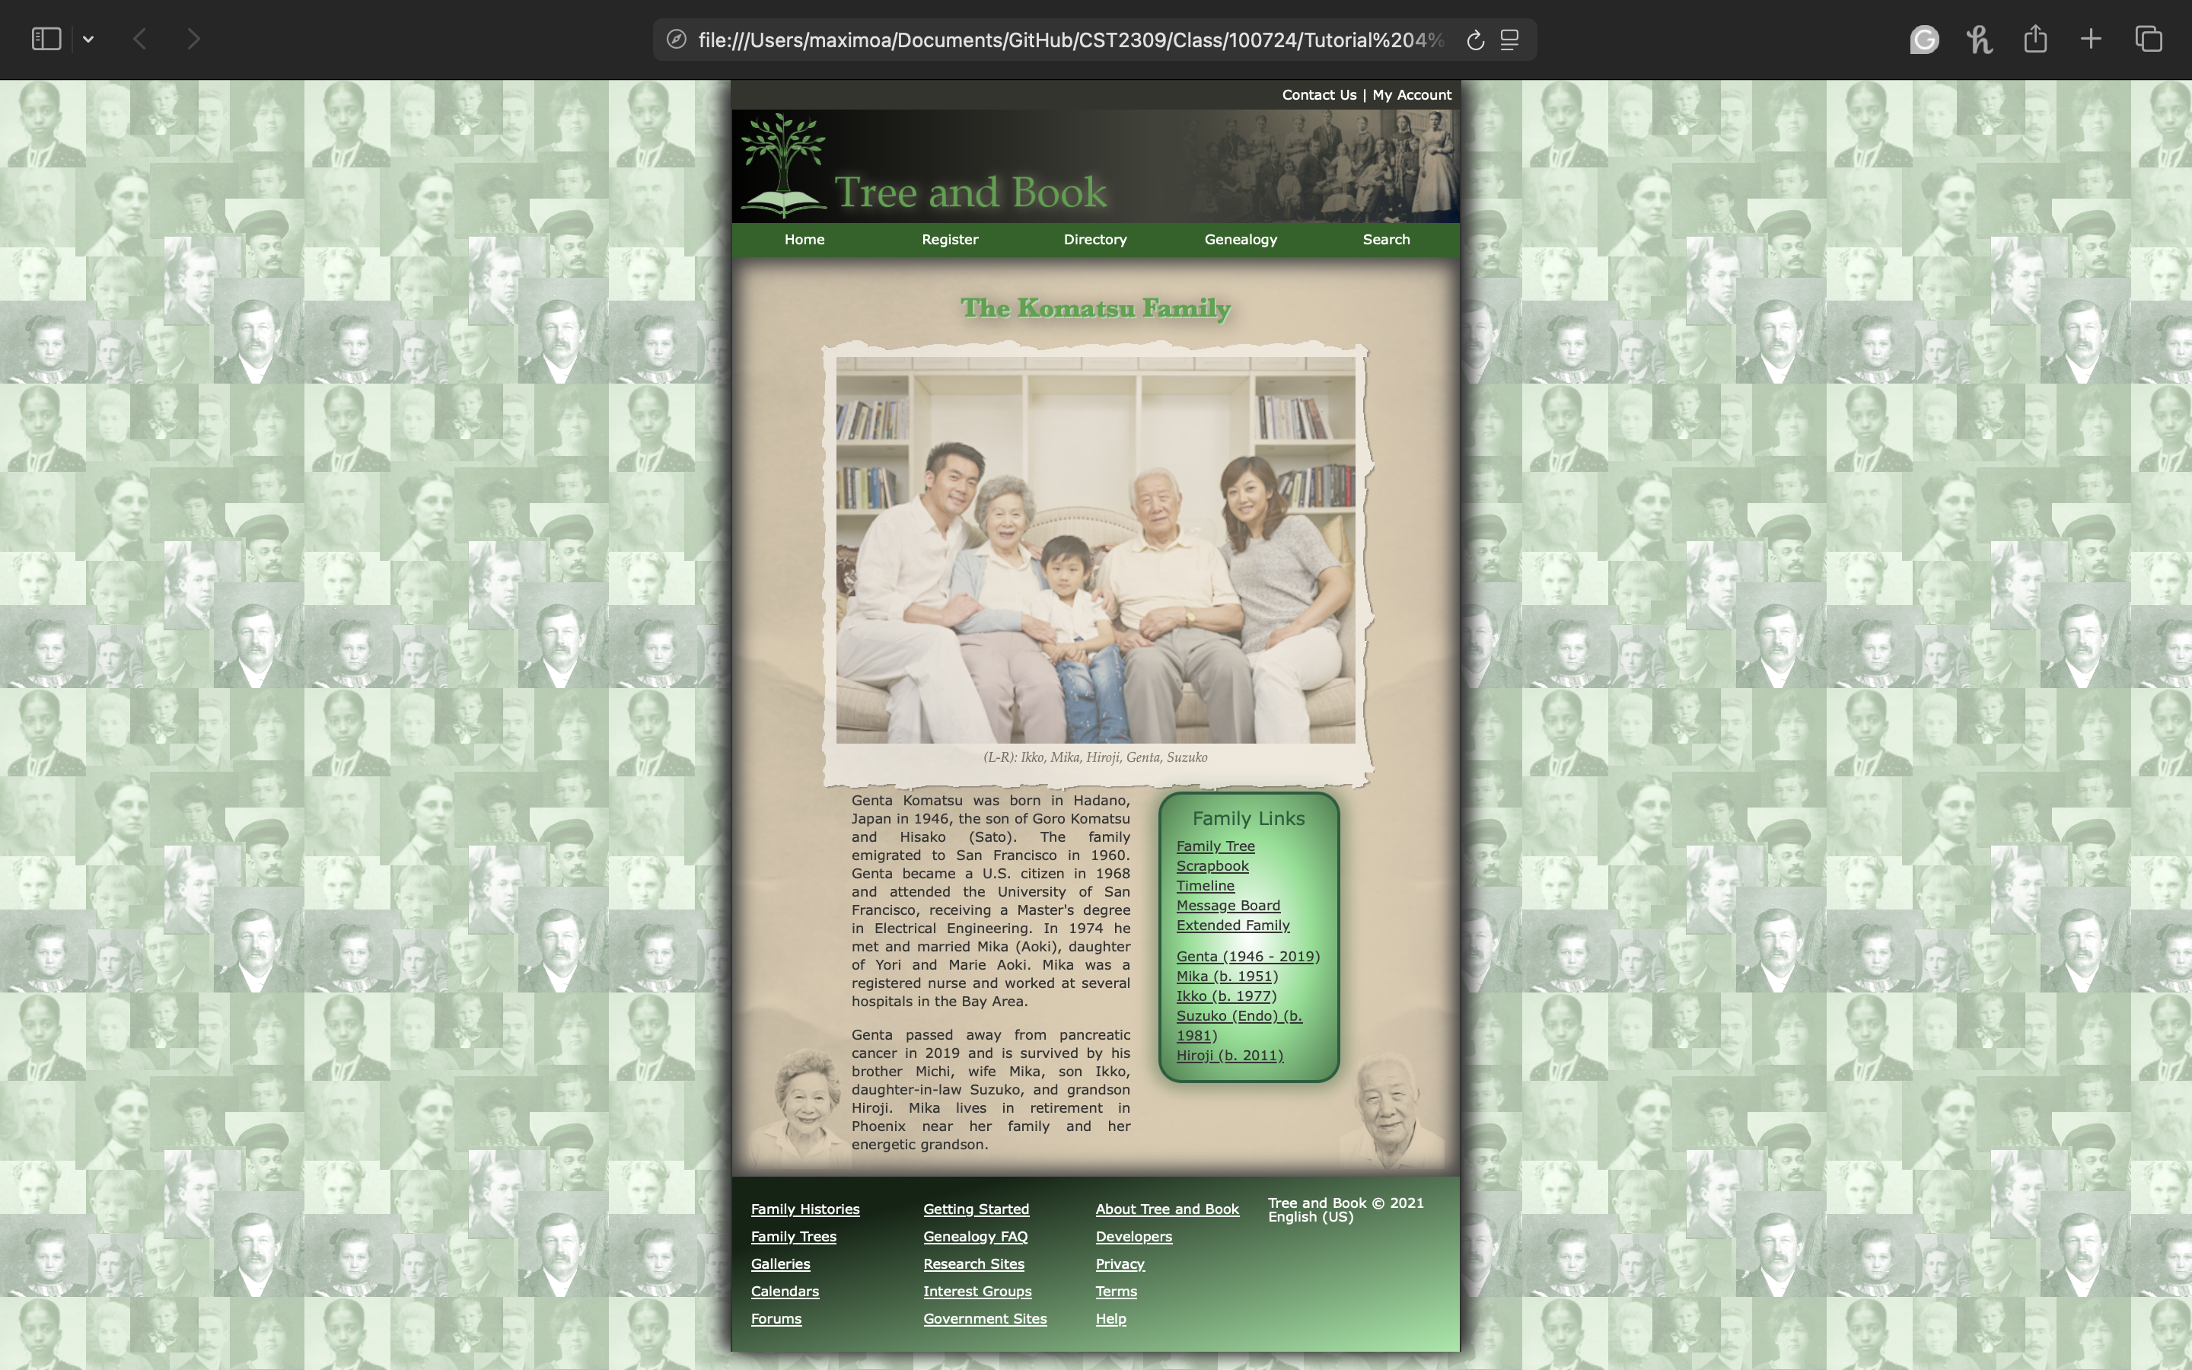

1. Complete the Session 4.2 Quick Check